**Competition**

**Software Requirements Specification**

**CEN 3031, Fall 2018**

**Modification history:**

|  |  |  |  |
| --- | --- | --- | --- |
| Version | Date | Who | Comment |
| v1.0.0a | 10/2/2018 | Whole Group | Added Emails, Shall statements, Software to be produce, assumption. |
| v1.1.0a | 10/9/2018 | Whole Group | Use Case diagram everything else minus the shall statements. |
| v1.1.1a | 10/11/2018 | Nicolas Caceda | Shall Statements |
| v1.1.2a | 11/13/2018 | Kamp Duong | Shall Statements/Use Case Revision |
| v1.1.3a | 11/20/2018 | Trevor Evans | Shall Statements/Use Case edits (added more description/removed un-invested shall statements). |
| v1.1.4a | 11/26/2018 | Trevor Evans | Use-Case rework + new Use-Case diagram |
| v1.1.5a | 11/30/2018 | Nicolas Caceda | Use-Case Change Description:  1-2,4,6-7,15-18-Added more description  5,8-9,13-14,19- redacted and replaced  Added 20 |

**Team Name:** @OfficialTeamName0

**Team Members:**

* Nicolas Caceda, nacaceda0973@eagle.fgcu.edu
* Luis Mendez, lamendez8190@eagle.fgcu.edu
* Trevor Evans, tlevans3543@eagle.fgcu.edu
* Brandon Schultz, baschultz2842@eagle.fgcu.edu
* Kamp Duong, kduong3310@eagle.fgcu.edu

**Contents of this Document**

Introduction

· Software to be Produced

· Definition, Acronyms, and Abbreviations

Product Overview

· Assumptions

· Use Case Diagram

· Use Case Descriptions

Specific Requirements

**SECTION 1: Introduction**

Software to be Produced:

* The software that is going to be produced is going to be a basketball competition tracker. The software is going to display a calendar and standard users are going to be able to view upcoming matches, while managing users can create teams and the admin user can schedule games. There is also going to be player profiles that all users can view and the admin can edit scores from games played.. Managing users can create team pages and fan users can view the team pages. Past games will be showing game statistics for that game.

Definitions, Acronyms, and Abbreviations:

* None

**SECTION 2: Product Overview**

Assumptions:

* This product will be available for use on systems running an os that can run the Java Virtual Machine (JVM).
* Standard user means anyone who does use the program for its intended purpose and isn’t a manager. eg. Athletes, fans.

Use Case Diagram:

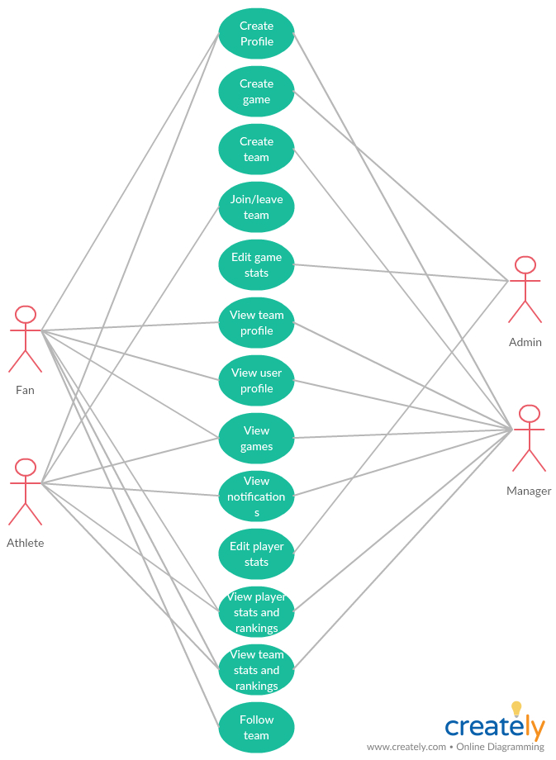

Use Case Descriptions:

* **Create Profile:** Managerial, athlete, and fan users will be able to create profiles.
* **Create game:** The administrator user has the option to create an games.
* **Create teams:** The managerial user will be able to create a team.
* **Join/Leave team:** The athlete user will request to join a team. The managerial user will approve or decline the athlete users request to join the team. The athlete user also has the option to leave team.
* **Edit game stats:** The administrator user will have access to edit game statistics.
* **View team profile:** Access to all users to view all team profiles.
* **View user profile:** Access to all users to view all user profiles.
* **View games:** Access to all users to view games.
* **View notifications:** Manager and athlete users will be able to view notifications relating to joining a team.
* **Edit player stats:** The administrator user has access to edit player statistics after the game was completed.
* **Edit games:** The administrator user will have access to edit games.
* **View player stats and ranking:** All users have access to view individual player statistics of wins/losses. All users have access to view individual player rankings.
* **View team stats and ranking:** All users have access to view individual team statistics of wins/losses. All users have access to view individual team rankings.
* **Follow team:** The Fan user have the ability to follow their favorite team.

**SECTION 3: Specific Requirements**

|  |
| --- |
| **No: 1** |
| **Statement:** The system shall allow managerial users to create a single team each. |
| **No: 2** |
| **Statement:** The system shall allow managerial users to edit their team roster by removing or inviting athlete users. |
| **No: 3** |
| **Statement:** The system shall allow athlete users to join teams. |
| **No: 4** |
| **Statement:** The system shall allow users to create profiles with a username (personal name) and password(alphanumeric, 5+ characters). |
| **No: 5** |
| **Statement:** The system shall display a graphic for win/loss statistics of teams and athletes. |
| **No: 6** |
| **Statement:** The system shall allow every user to view athlete user profiles (win/loss and team). |
| **No: 7** |
| **Statement:** The system shall allow users to view team profiles displaying rosters and win/loss ratio. |
| **No: 8** |
| **Statement:** The system shall allow the admin user to create games by date and teams involved. |
| **No: 9** |
| **Statement:** The system shall allow the admin user to edit games date and teams involved. |
| **No: 10** |
| **Statement:** The system shall allow all users to view games (date and teams involved). |
| **No: 11** |
| **Statement:** The system shall allow athlete users to leave teams. |
| **No: 12** |
| **Statement:** The system shall display statistics of past games’ dates, teams, final scores. |
| **No: 13** |
| **Statement:** The system shall allow the admin user to edit game statistics, which team won/loss. |
| **No: 14** |
| **Statement:** The system shall allow the admin user to edit player statistics, win/loss ratio. |
| **No: 15** |
| **Statement:** The system shall allow users to view player win/loss rankings. |
| **No: 16** |
| **Statement:** The system shall allow users to view team win/loss rankings. |
| **No: 17** |
| **Statement:** The system shall allow users to view player statistics for games played, won, and lost. |
| **No: 18** |
| **Statement:** The system shall display notifications for players invited to teams by a manager. |
| **No: 19** |
| **Statement:** The system shall allow users to follow teams. |
| **No: 20** |
| **Statement:** The system shall allow users to view any possible date. |

Template created by G. Walton (GWalton@mail.ucf.edu) on Aug 30, 1999 and last updated Aug 15, 2000; updated by A. Koufakou, Aug 2014

This page last modified by @OfficalTeamName0 on October 2, 2018.